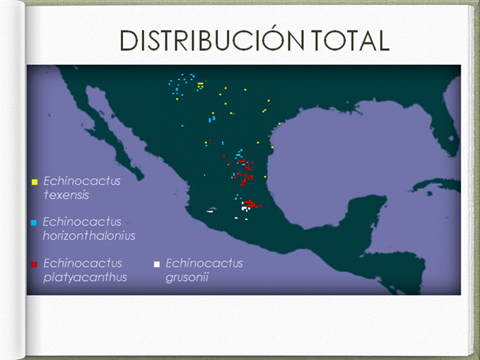

Figura 1. Distribución total de las especies de Echinocactus seleccionadas en el Coloquio Intrapreparatoriano 2015.

Cuadro 1. Distribución de especies de murciélagos en países americanos.

 | Leptonycteris curasoae | L. nivalis | L. yerbabuenae | Myotis evotis | M. yumanensis | M. lucifugus | M. velifer | M. nigricans | M. thysanodes | Furipterus horrens | Amorphochilus schnablii | Mormoops megalophylla | Pteronotus parnellii | P. davyi | Natalus stramineus | N. tumidirostris | Thyroptera tricolor | T. discifera | T. lavali | Noctilio albiventris
Canadá | 0 | 0 | 0 | 1 | 1 | 1 | 0 | 0 | 0 | 0 | 0 | 0 | 0 | 0 | 0 | 0 | 0 | 0 | 0 | 0
Estados Unidos | 1 | 1 | 1 | 1 | 1 | 1 | 1 | 0 | 1 | 0 | 0 | 1 | 0 | 0 | 0 | 0 | 0 | 0 | 0 | 0
México | 1 | 1 | 1 | 1 | 1 | 1 | 1 | 1 | 1 | 0 | 0 | 1 | 1 | 1 | 1 | 0 | 1 | 0 | 0 | 0
Guatemala | 1 | 0 | 0 | 0 | 0 | 0 | 1 | 1 | 1 | 0 | 0 | 1 | 1 | 1 | 1 | 0 | 0 | 0 | 0 | 1
Colombia | 1 | 0 | 0 | 0 | 0 | 0 | 0 | 1 | 0 | 0 | 0 | 1 | 1 | 0 | 1 | 1 | 1 | 1 | 0 | 1
El Salvador | 1 | 0 | 0 | 0 | 0 | 0 | 1 | 1 | 0 | 0 | 0 | 0 | 1 | 1 | 0 | 0 | 0 | 0 | 0 | 1
Venezuela | 1 | 0 | 0 | 0 | 0 | 0 | 0 | 1 | 0 | 0 | 0 | 0 | 1 | 1 | 0 | 1 | 0 | 0 | 0 | 1
Brasil | 0 | 0 | 1 | 0 | 0 | 0 | 0 | 1 | 0 | 1 | 0 | 0 | 1 | 0 | 0 | 0 | 1 | 0 | 0 | 1
Honduras | 0 | 0 | 1 | 0 | 0 | 0 | 0 | 1 | 0 | 0 | 0 | 1 | 1 | 1 | 1 | 0 | 0 | 0 | 0 | 1
Argentina | 0 | 0 | 0 | 0 | 0 | 0 | 0 | 1 | 0 | 0 | 0 | 0 | 0 | 0 | 0 | 0 | 0 | 0 | 0 | 0
Costa Rica | 0 | 0 | 0 | 0 | 0 | 0 | 0 | 1 | 0 | 1 | 0 | 0 | 1 | 1 | 0 | 0 | 1 | 0 | 0 | 1
Surinam | 0 | 0 | 0 | 0 | 0 | 0 | 0 | 1 | 0 | 1 | 0 | 0 | 1 | 0 | 0 | 0 | 1 | 0 | 0 | 0
Ecuador | 0 | 0 | 0 | 0 | 0 | 0 | 0 | 1 | 0 | 0 | 1 | 1 | 0 | 0 | 0 | 0 | 1 | 0 | 1 | 1
Perú | 0 | 0 | 0 | 0 | 0 | 0 | 0 | 1 | 0 | 1 | 1 | 1 | 1 | 1 | 0 | 0 | 1 | 1 | 1 | 1
Paraguay | 0 | 0 | 0 | 0 | 0 | 0 | 0 | 1 | 0 | 0 | 0 | 0 | 0 | 0 | 0 | 0 | 0 | 0 | 0 | 1
Panamá | 0 | 0 | 0 | 0 | 0 | 0 | 0 | 1 | 0 | 0 | 0 | 0 | 1 | 0 | 0 | 0 | 0 | 1 | 0 | 1

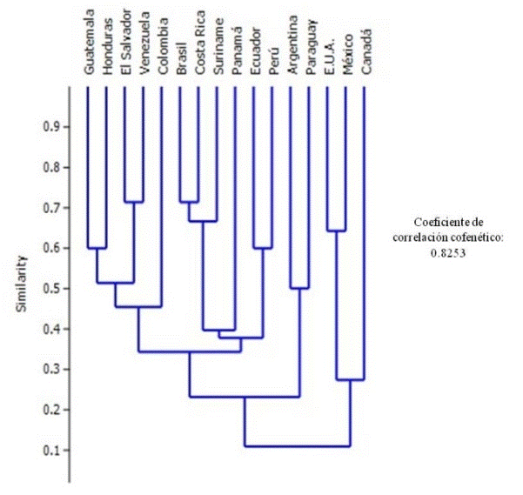

Figura 2. Dendrograma de similitud de Jaccard entre los países de América.

